Ripped Foil - Monkeys

Zeynep Civelek

July 08, 2020

## Exploring data

The structure of the data is shown below with all the variable names and levels of measurement.

## 'data.frame': 608 obs. of 11 variables:  
## $ id : Factor w/ 19 levels "Alba","Bear",..: 15 15 15 15 15 15 15 15 15 15 ...  
## $ sex : Factor w/ 2 levels "f","m": 2 2 2 2 2 2 2 2 2 2 ...  
## $ age : int 8 8 8 8 8 8 8 8 8 8 ...  
## $ order : Factor w/ 2 levels "food-stick at test",..: 1 1 1 1 1 1 1 1 1 1 ...  
## $ boxtype : Factor w/ 2 levels "blue","pink": 1 1 1 1 1 1 1 1 1 1 ...  
## $ phase : Factor w/ 2 levels "test","transfer": 1 1 1 1 1 1 1 1 1 1 ...  
## $ sessionno: int 1 1 1 1 1 1 1 1 2 2 ...  
## $ trialno : int 1 2 3 4 5 6 7 8 9 10 ...  
## $ correct : int 1 1 1 1 1 1 1 1 1 1 ...  
## $ trialtype: Factor w/ 2 levels "food","stick": 1 1 1 1 1 1 1 1 1 1 ...  
## $ phase2 : Factor w/ 2 levels "1","2": 1 1 1 1 1 1 1 1 1 1 ...

Exploring the warm-up 1 (locating the reward when there is no foil covering the cups) and warm-up 2 phases (locating the reward when the cups are covered with foil).

**In warm-up 1, monkeys got up to 18 sessions to reach criterion and in warm-up 2, up to 6 sessions (or they'd receive up to 10 sessions). The minimum number of sessions to reach criterion was 2 (14/16 correct)**

## Histograms for Warm-up 1 and Warm-up 2 Phases

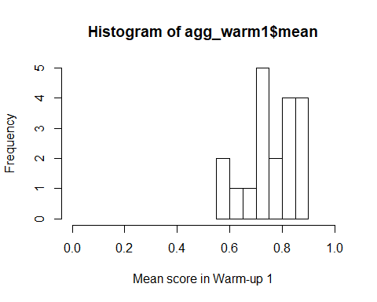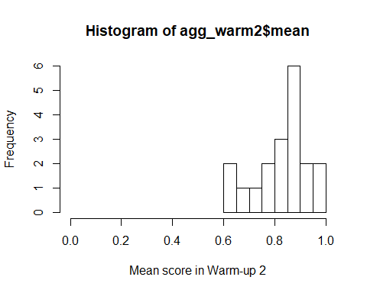

I then aggregated the trial-by-trial data to create one score per monkey for Test and Transfer phases so I can see the distribution of scores.

## Histograms for Test and Transfer Phases and the overall score

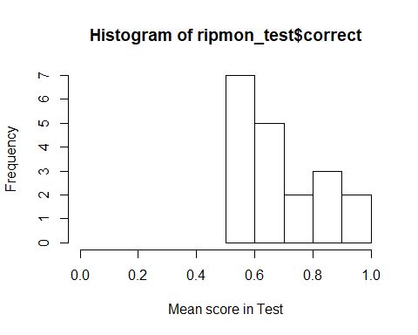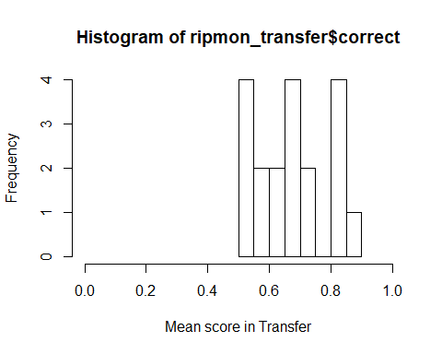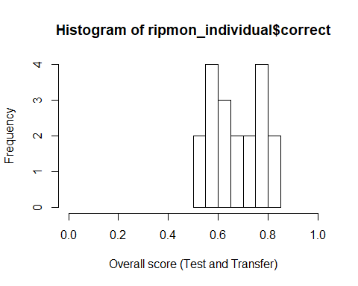

## Preparation of the data for running the GLMM

* Scaling age and trial number
* Coding categorical variables as dummy variables
* Centering the slopes.

## Full model

contr<-glmerControl(optimizer="bobyqa", optCtrl=list(maxfun=10000000))  
full=glmer(correct ~ trialtype*phase+z.trialno+z.age+sex+(1|id)+(0+z.trialno+phase.transfer.c+trialtype.food.c|id),data=ripmon1, family=binomial, control=contr)

The full model does not include box type (the location of the blue/pink box) as a random effect anymore due to convergence issues. The correlations between random slope and random intercept are not included either.

## Model assumptions

#### Distribution of random effects

I don’t understand what happened here with id, z.trial no. Any ideas?

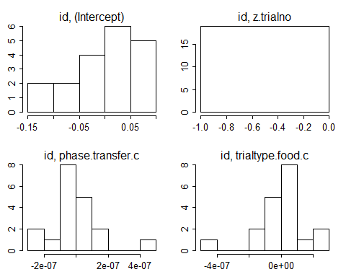

#### Model stability

I could not calculate stability for the monkey data. I’ll look into this.

#### Multicollinearity

## trialtype phase z.trialno z.age sex   
## 1.003 1.003 1.000 1.030 1.030

## Null model

null=glmer(correct~z.trialno+(1|id)+(0+z.trialno+phase.transfer.c+trialtype.food.c|id),data=ripmon1, family=binomial, control=contr)

**Added trial no to the null model to control for its effects.**

## Full and Null comparison

## Data: ripmon1  
## Models:  
## null: correct ~ z.trialno + (1 | id) + (0 + z.trialno + phase.transfer.c +   
## null: trialtype.food.c | id)  
## full: correct ~ trialtype * phase + z.trialno + z.age + sex + (1 |   
## full: id) + (0 + z.trialno + phase.transfer.c + trialtype.food.c |   
## full: id)  
## npar AIC BIC logLik deviance Chisq Df Pr(>Chisq)   
## null 9 781.35 821.04 -381.68 763.35   
## full 14 777.86 839.61 -374.93 749.86 13.488 5 0.019 *  
## ---  
## Signif. codes: 0 '***' 0.001 '**' 0.01 '*' 0.05 '.' 0.1 ' ' 1

**The full model is significantly different than the null model.**

## Model output

#### Coefficients

## Estimate Std. Error z value Pr(>|z|)  
## (Intercept) 0.162 0.239 0.678 0.498  
## trialtypefood 0.397 0.267 1.488 0.137  
## phasetransfer -0.077 0.257 -0.298 0.766  
## z.trialno -0.012 0.088 -0.134 0.894  
## z.age -0.125 0.096 -1.310 0.190  
## sexm 0.603 0.210 2.866 0.004  
## trialtypefood:phasetransfer 0.072 0.397 0.182 0.856

#### Individual predictor: Likelihood tests

## Single term deletions  
##   
## Model:  
## correct ~ trialtype * phase + z.trialno + z.age + sex + (1 |   
## id) + (0 + z.trialno + phase.transfer.c + trialtype.food.c |   
## id)  
## npar AIC LRT Pr(Chi)   
## <none> 777.86   
## z.trialno 1 775.77 -0.094 1.000   
## z.age 1 777.36 1.501 0.221   
## sex 1 782.67 6.808 0.009 **  
## trialtype:phase 1 775.77 -0.089 1.000   
## ---  
## Signif. codes: 0 '***' 0.001 '**' 0.01 '*' 0.05 '.' 0.1 ' ' 1

**There is a significant effect of sex. The interaction term is not significant.**

**I will remove the non-significant interaction term to reduce the model.**

## Reduced model without the interaction

## Full model 2

full2=glmer(correct ~ trialtype+phase+z.trialno+z.age+sex+(1|id)+(0+z.trialno+phase.transfer.c+trialtype.food.c|id),data=ripmon1, family=binomial, control=contr)  
summary(full2)

## Generalized linear mixed model fit by maximum likelihood (Laplace  
## Approximation) [glmerMod]  
## Family: binomial ( logit )  
## Formula: correct ~ trialtype + phase + z.trialno + z.age + sex + (1 |   
## id) + (0 + z.trialno + phase.transfer.c + trialtype.food.c | id)  
## Data: ripmon1  
## Control: contr  
##   
## AIC BIC logLik deviance df.resid   
## 775.8 833.1 -374.9 749.8 595   
##   
## Scaled residuals:   
## Min 1Q Median 3Q Max   
## -1.9424 -1.1732 0.5782 0.7003 1.0556   
##   
## Random effects:  
## Groups Name Variance Std.Dev. Corr   
## id (Intercept) 0.027250 0.16508   
## id.1 z.trialno 0.002545 0.05045   
## phase.transfer.c 0.019233 0.13868 1.00   
## trialtype.food.c 0.026135 0.16166 -1.00 -1.00  
## Number of obs: 608, groups: id, 19  
##   
## Fixed effects:  
## Estimate Std. Error z value Pr(>|z|)   
## (Intercept) 0.14054 0.20512 0.685 0.49324   
## trialtypefood 0.43588 0.18422 2.366 0.01798 *   
## phasetransfer -0.04456 0.18361 -0.243 0.80824   
## z.trialno -0.01230 0.08904 -0.138 0.89014   
## z.age -0.12314 0.09601 -1.283 0.19962   
## sexm 0.61434 0.20563 2.988 0.00281 **  
## ---  
## Signif. codes: 0 '***' 0.001 '**' 0.01 '*' 0.05 '.' 0.1 ' ' 1  
##   
## Correlation of Fixed Effects:  
## (Intr) trltyp phstrn z.trln z.age   
## trialtypefd -0.387   
## phasetrnsfr -0.412 -0.103   
## z.trialno 0.001 -0.030 0.025   
## z.age 0.116 -0.006 -0.012 -0.001   
## sexm -0.666 0.027 0.013 -0.003 -0.180  
## convergence code: 0  
## boundary (singular) fit: see ?isSingular

I get the following warning: convergence code: 0, boundary (singular) fit: see ?isSingular.

**The model summary show that there is a significant effect of sex and trial type.**

## Null model 2

null2<-glmer(correct~ z.trialno + (1|id)+(0+z.trialno+phase.transfer.c+trialtype.food.c|id),data=ripmon1, family=binomial, control=contr)

## Full and null model (2) comparion

## Data: ripmon1  
## Models:  
## null2: correct ~ z.trialno + (1 | id) + (0 + z.trialno + phase.transfer.c +   
## null2: trialtype.food.c | id)  
## full2: correct ~ trialtype + phase + z.trialno + z.age + sex + (1 |   
## full2: id) + (0 + z.trialno + phase.transfer.c + trialtype.food.c |   
## full2: id)  
## npar AIC BIC logLik deviance Chisq Df Pr(>Chisq)   
## null2 9 781.35 821.04 -381.68 763.35   
## full2 13 775.77 833.11 -374.89 749.77 13.577 4 0.009 **  
## ---  
## Signif. codes: 0 '***' 0.001 '**' 0.01 '*' 0.05 '.' 0.1 ' ' 1

**There is a significant difference between the full and the null model.**

## Model output

#### Coefficients

## Estimate Std. Error z value Pr(>|z|)  
## (Intercept) 0.141 0.205 0.685 0.493  
## trialtypefood 0.436 0.184 2.366 0.018  
## phasetransfer -0.045 0.184 -0.243 0.808  
## z.trialno -0.012 0.089 -0.138 0.890  
## z.age -0.123 0.096 -1.283 0.200  
## sexm 0.614 0.206 2.988 0.003

#### Individual predictors : Likelihood ratio tests

## Single term deletions  
##   
## Model:  
## correct ~ trialtype + phase + z.trialno + z.age + sex + (1 |   
## id) + (0 + z.trialno + phase.transfer.c + trialtype.food.c |   
## id)  
## npar AIC LRT Pr(Chi)   
## <none> 775.77   
## trialtype 1 778.99 5.216 0.022 *   
## phase 1 773.83 0.059 0.808   
## z.trialno 1 773.79 0.019 0.890   
## z.age 1 775.37 1.592 0.207   
## sex 1 781.37 7.593 0.006 **  
## ---  
## Signif. codes: 0 '***' 0.001 '**' 0.01 '*' 0.05 '.' 0.1 ' ' 1

**The trial type and sex are significant predictors of performance.**

#### Calculating effect sizes for the final model

## R2m R2c  
## theoretical 0.03829153 0.04999888  
## delta 0.02805275 0.03662966

Here we look at the row headed delta. Marginal R-squared is the variance explained by the fixed effects and the conditional R-squared is the variance explained by the fixed and random effects (the model).

## Plotting the findings

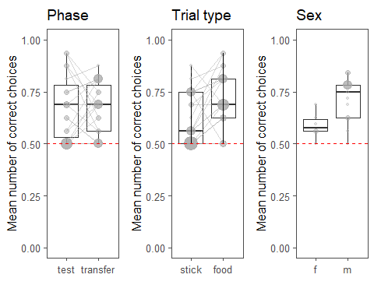 We will probably not include sex in the paper and it'll just be phase and trial type. Overall, monkeys performed better in food-stick trials than in stick-food trials and males better than females. Performance in Test and Transfer Phases did not differ.

## Test against chance

I’m keeping the code here so you can have a look if I did it correctly Christoph. Thanks!

#### Test and transfer phase

testphase <-ripmon1%>%  
 filter(phase == "test")  
testchance <- glmer(correct ~ 1 + (z.trialno | id),data= testphase, family=binomial)  
summary(testchance)

## Generalized linear mixed model fit by maximum likelihood (Laplace  
## Approximation) [glmerMod]  
## Family: binomial ( logit )  
## Formula: correct ~ 1 + (z.trialno | id)  
## Data: testphase  
##   
## AIC BIC logLik deviance df.resid   
## 386.3 401.2 -189.2 378.3 300   
##   
## Scaled residuals:   
## Min 1Q Median 3Q Max   
## -1.8788 -1.2118 0.5815 0.7098 0.8815   
##   
## Random effects:  
## Groups Name Variance Std.Dev. Corr   
## id (Intercept) 0.24588 0.4959   
## z.trialno 0.01674 0.1294 -1.00  
## Number of obs: 304, groups: id, 19  
##   
## Fixed effects:  
## Estimate Std. Error z value Pr(>|z|)   
## (Intercept) 0.7839 0.1694 4.628 3.69e-06 ***  
## ---  
## Signif. codes: 0 '***' 0.001 '**' 0.01 '*' 0.05 '.' 0.1 ' ' 1  
## convergence code: 0  
## boundary (singular) fit: see ?isSingular

**The intercept is significant: Performance in Test phase is above chance level.**

transferphase <-ripmon1%>%  
 filter(phase == "transfer")  
transferchance <- glmer(correct ~ 1 + (z.trialno | id),data= transferphase, family=binomial)  
summary(transferchance)

## Generalized linear mixed model fit by maximum likelihood (Laplace  
## Approximation) [glmerMod]  
## Family: binomial ( logit )  
## Formula: correct ~ 1 + (z.trialno | id)  
## Data: transferphase  
##   
## AIC BIC logLik deviance df.resid   
## 393.1 407.9 -192.5 385.1 300   
##   
## Scaled residuals:   
## Min 1Q Median 3Q Max   
## -1.4763 -1.3953 0.6845 0.6980 0.7192   
##   
## Random effects:  
## Groups Name Variance Std.Dev. Corr   
## id (Intercept) 2.040e-02 0.142819   
## z.trialno 6.309e-05 0.007943 -1.00  
## Number of obs: 304, groups: id, 19  
##   
## Fixed effects:  
## Estimate Std. Error z value Pr(>|z|)   
## (Intercept) 0.7164 0.1278 5.607 2.06e-08 ***  
## ---  
## Signif. codes: 0 '***' 0.001 '**' 0.01 '*' 0.05 '.' 0.1 ' ' 1  
## convergence code: 0  
## boundary (singular) fit: see ?isSingular

**Performance in Transfer phase is above chance level as well. And there is no significant difference between the monkeys' performances in Test and Transfer phases.**

#### Trial type

## Generalized linear mixed model fit by maximum likelihood (Laplace  
## Approximation) [glmerMod]  
## Family: binomial ( logit )  
## Formula: correct ~ 1 + (z.trialno | id)  
## Data: sticktrials  
##   
## AIC BIC logLik deviance df.resid   
## 409.2 424.1 -200.6 401.2 300   
##   
## Scaled residuals:   
## Min 1Q Median 3Q Max   
## -1.3237 -1.2907 0.7602 0.7705 0.7793   
##   
## Random effects:  
## Groups Name Variance Std.Dev. Corr  
## id (Intercept) 0.0091697 0.09576   
## z.trialno 0.0007135 0.02671 1.00  
## Number of obs: 304, groups: id, 19  
##   
## Fixed effects:  
## Estimate Std. Error z value Pr(>|z|)   
## (Intercept) 0.5255 0.1210 4.342 1.41e-05 ***  
## ---  
## Signif. codes: 0 '***' 0.001 '**' 0.01 '*' 0.05 '.' 0.1 ' ' 1  
## convergence code: 0  
## boundary (singular) fit: see ?isSingular

## Generalized linear mixed model fit by maximum likelihood (Laplace  
## Approximation) [glmerMod]  
## Family: binomial ( logit )  
## Formula: correct ~ 1 + (z.trialno | id)  
## Data: foodtrials  
##   
## AIC BIC logLik deviance df.resid   
## 365.6 380.5 -178.8 357.6 300   
##   
## Scaled residuals:   
## Min 1Q Median 3Q Max   
## -1.9489 -1.2872 0.5454 0.6367 0.8379   
##   
## Random effects:  
## Groups Name Variance Std.Dev. Corr   
## id (Intercept) 0.19943 0.4466   
## z.trialno 0.02154 0.1467 -1.00  
## Number of obs: 304, groups: id, 19  
##   
## Fixed effects:  
## Estimate Std. Error z value Pr(>|z|)   
## (Intercept) 0.9678 0.1657 5.839 5.25e-09 ***  
## ---  
## Signif. codes: 0 '***' 0.001 '**' 0.01 '*' 0.05 '.' 0.1 ' ' 1  
## convergence code: 0  
## boundary (singular) fit: see ?isSingular

**Monkeys performed above chance levels in both stick-food and food-stick trials.**

## Correcting the p-values for the post-hoc tests using Hochberg correction (in the order: test, transfer, stick-food, food-stick)

pvalues <- c(3.69e-06, 2.06e-08, 1.41e-05, 5.25e-09)  
p.adjust(pvalues, method="hochberg")

## [1] 7.38e-06 6.18e-08 1.41e-05 2.10e-08

## For comparison purposes with children, I run two additional tests

#### First trial performance in Transfer phase: Is performance above chance?

ripmon_1st_trial <- ripmon1 %>%  
 filter(phase=="transfer" & sessionno=="1", trialno=="1")  
#I am fitting a glm with binomial error structure for the first trial transfer phase analysis and not a mixed model given that it only includes one data point per subject.  
firsttrialchance <- glm(correct ~ 1, data= ripmon_1st_trial, family=binomial)  
summary(firsttrialchance)

##   
## Call:  
## glm(formula = correct ~ 1, family = binomial, data = ripmon_1st_trial)  
##   
## Deviance Residuals:   
## Min 1Q Median 3Q Max   
## -1.133 -1.133 -1.133 1.222 1.222   
##   
## Coefficients:  
## Estimate Std. Error z value Pr(>|z|)  
## (Intercept) -0.1054 0.4595 -0.229 0.819  
##   
## (Dispersion parameter for binomial family taken to be 1)  
##   
## Null deviance: 26.287 on 18 degrees of freedom  
## Residual deviance: 26.287 on 18 degrees of freedom  
## AIC: 28.287  
##   
## Number of Fisher Scoring iterations: 3

**(Question:** Is this the correct way of looking at chance performance here?)

**No, performance in the first trial of transfer phase does not differ from chance.**

#### Performance of monkeys in the first 8 trials of Test phase: Is it above chance level?

## Generalized linear mixed model fit by maximum likelihood (Laplace  
## Approximation) [glmerMod]  
## Family: binomial ( logit )  
## Formula: correct ~ 1 + (z.trialno | id)  
## Data: ripmon_test8  
##   
## AIC BIC logLik deviance df.resid   
## 217.7 229.8 -104.8 209.7 148   
##   
## Scaled residuals:   
## Min 1Q Median 3Q Max   
## -1.1354 -1.0737 0.8496 0.9238 0.9747   
##   
## Random effects:  
## Groups Name Variance Std.Dev. Corr   
## id (Intercept) 0.03089 0.1758   
## z.trialno 0.02832 0.1683 -1.00  
## Number of obs: 152, groups: id, 19  
##   
## Fixed effects:  
## Estimate Std. Error z value Pr(>|z|)  
## (Intercept) 0.1573 0.1685 0.934 0.351  
## convergence code: 0  
## boundary (singular) fit: see ?isSingular

**No, they are at chance level in the first 8 trials of Test phase.**